9. High Catch
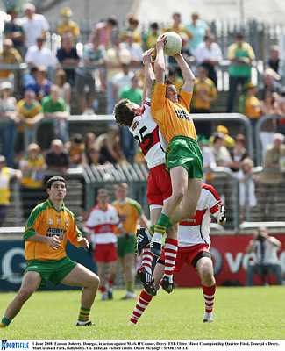

- Introduce
- Demonstrate
- Execute
- Attend

Moving forward, extend upwards

The High Catch is one of the most spectacular
techniques in Gaelic Football and is used to field
the ball from the air. It is used in particular to win
possession from a kick out or long pass.

Extend the arms fully above the head

Look out for:
- Now swinging the non jumping leg forward
- Not extending arms
- Not securing the ball
- Jumping too early/late

Catch the ball slightly in front of the head

Secure the ball to the chest
Pg. 105-110 FFD

High Catch

Practice the Technique


Partner Catch
Player in turn throws the ball up for their partner to High Catch

Move and Catch
A jogs backwards, throws the ball up for B to run onto and High Catch

Opposed Catch
One player in the middle High Catches the ball while the other provides opposition

Develop the Skill


Prisoner Ball
Players kick the ball to the opposition; if the ball touches the ground the nearest player joins the other team
One on One
Coach throws the ball for the attacker to High Catch and kick for a score, defender tries to block it.



